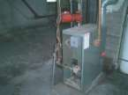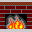

Residential structure fires
The 1999-2002 annual averages for Heating equipment fires including wood stoves accounted for:
- 60,000 fires
- 360 Civilian deaths
- 1,330 Civilian injuries
- $670,000.00 Direct property damage

Chimney and Woodstove Fire Safety
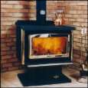
Purchasing

- Be sure the stove you are purchasing to burn wood or coal is approved by
the Underwriter’s Laboratory or another recognized testing laboratory.

Installation

- A building permit must be obtained prior to the installation of fireplaces,
wood or coal burning stoves. They must be inspected by the local building
inspector prior to their initial use as required by the New York State
Building Code.

- Allow at least 36 inches of space around the appliance to prevent
combustibles from coming into contact with a heat source.

- Solid fuel heating appliances cannot share a common flue with chimney
flues utilized by other solid fuel, fossil fuel, or gas fired appliances.

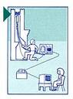

Inspections

- Have the chimney and flue inspected by a qualified mason or sweep
prior to use. Cracks in the flue or mortar joints can allow flames and
heated gases to extend into the structure.

Proper Use

- Most chimney fires occur due to a buildup of creosote, a tarry
by-product of burning wood. Have your chimney flue cleaned
before each heating season. Burn only dry, well-seasoned,
hardwood to reduce creosote accumulation.

- Do not use flammable liquids to start the fire.

- Never leave children unattended near the stove.

- Check that the damper is open before lighting the fire. Failure to do so can
result in an accumulation of smoke and carbon monoxide within the home.
Do not close the damper before the fire has died out and the embers are
cold.

- Use a fireplace screen to prevent flying sparks and embers from falling
out onto the floor.

- Install and maintain smoke alarms and carbon monoxide detectors to
Provide protection for your family.

What you should know about Creosote

- Fireplaces and wood stoves are designed to safely contain wood-fueled fires,
while providing heat for the home. The homes chimneys have the job of expelling
the by-products of combustion – the substances given off when wood burns.
These include smoke, water vapor, gases, unburned wood particles,
hydrocarbon volatiles, tar and assorted minerals. As these substances are carried
up the fireplace or wood stove chimney, and flow up into the relatively cooler chimney,
condensation occurs. The resulting residue that sticks to the inner walls of the
chimney is called creosote.

- A dirty chimney with only a quarter inch of soot contains the highly
flammable substance called creosote. An innocent, errant spark
from your cozy woodstove or fireplace could easily ignite this substance
into a roaring fire.

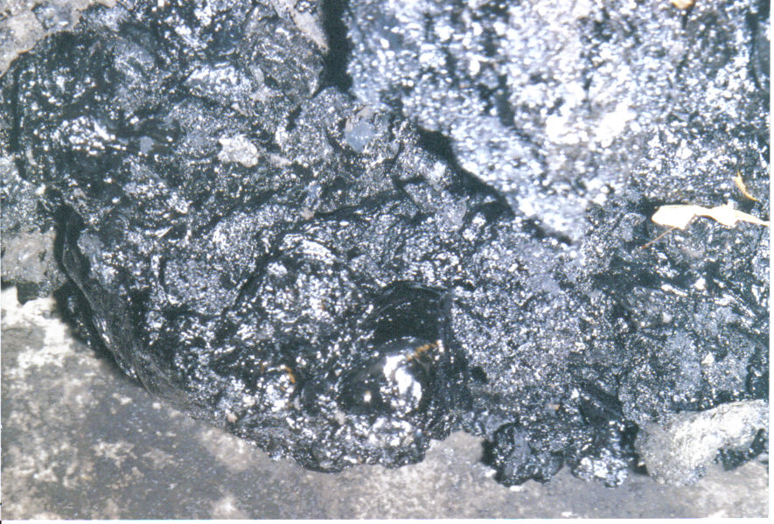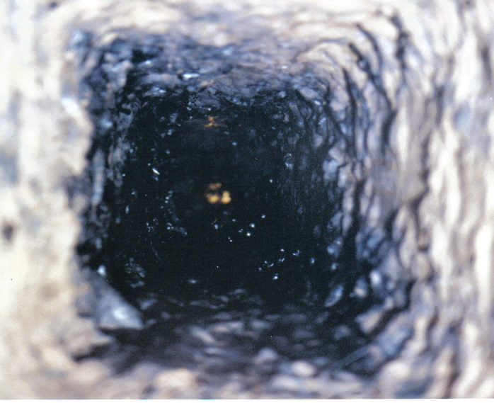
Creosote removed from the chimney Looking down a chimney lined with creosote

- Your professional sweep will be able to suggest valid corrective measures
in making your home safe from chimney fires. Creosote accumulates no
matter what kind of wood is burned.

- In one year more than 60,000 chimney fires burn in the United States
with deaths increasing at a rate of 69%.

- Dirty chimneys can burn down buildings and take lives.

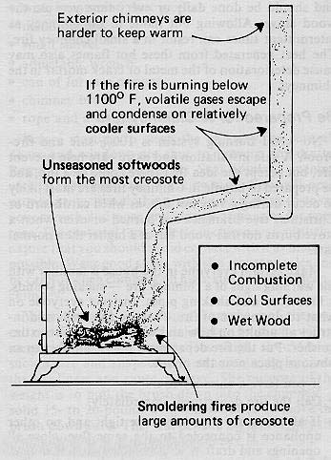

Check your wood stove or fireplace chimney this year and make sure you will not
become one of the unfortunate who have a fire as a result of creosote buildup.

If you have any suspicions or questions after your inspection please call an
expert for your own protection.

